*Statistical Approach to Synthetic Aperture Radar Assessment of Beirut Explosion and Human Recovery Efforts*

Caleb Buffa   
*Department of Earth and Atmospheric Science*  
*Saint Louis University*Saint Louis, United States  
buffacm@slu.edu

*Abstract*—This research leverages Google Earth Engine’s API, datasets, and methods to estimate the human impact of large explosions. Using The 2020 Beirut explosion as a case study, this research achieved an accuracy of 77% in its estimation of affected population.

Keywords—Synthetic Aperture Radar, Human Recovery

# Introduction

Damage assessments (DA), commonly identified by their military applications, are well-known for their ability to provide detailed analytics of remote weapons’ impact on targets with the primary purpose of assessing their effectiveness (Evans, 1996). DAs also serve as an important tool outside of defense applications, and with the commercialization of highly capable remote sensing technologies, open-source assessments have become widely used and accepted for contextualization of major international events in real time( Novikov et al, 2018). Namely, upon reports of a large explosion being released, international communities, agencies, and governments are generally quick to seek context regarding what happened and why.

To that end, the proliferation of technologies such as Synthetic Aperture Radar (SAR) has demonstrated great promise to the field. SAR, leveraging an artificial satellite antenna to increase spatial resolution, actively emits electromagnetic radiation (EMR) between 0.4 and 0.7 micrometer wavelengths (C-band). By recording the degree of EMR detected by the sensor, in relation to its emittance, sensors can quantify phase difference. This phase difference can then be preprocessed, visualized, and analyzed into a high-resolution image of the phenomena in question. A significant benefit of the active nature of SAR, is it ability to penetrate cloud cover and operate in both daytime and night. Further, the European Space Agency’s (ESA) Sentinel-1 satellite obtains images with a spatial and temporal resolution as little as 10m x 10m and 6 days. Thus, Sentinel-1 provides nearly complete coverage of any event every 6 days at a spatial resolution adequate to assess large explosive damage to the Earth’s surface as well as built structures.

To further enhance real-time DAs, Sentinel-1 imagery is provided in open-source format, and is available in Google Earth Engine (GEE), preprocessed and ready for analysis within two days of images being collected. Prior to being publicly available, GEE preprocesses by removing external noise, radiometric calibration, and finally geometrically correcting and outputting the data in both decibels and unitless floating-point digital numbers. Thus, leveraging Sentinel-1’s SAR capabilities within GEE provides the open-source community with high resolution imagery suitable for DAs within one week of an event occurring, if not sooner.

To date, much research has been conducted on the applications of SAR to change detection studies (Rignot and Van Zyl, 1993; Bazi, Bruzzone, and Melgani, 2005; Inglada and Mercier, 2007; Samadi, Akbrarizadeh, and Kaabi, 2019). Further, its applications to explosive damage assessments have also been well researched and demonstrated successful results (Chen et al., 2019; Hajeb, Karimzadeh, and Fallahi, 2020; Guida et al. 2018). Thus, the application of SAR for change and explosive damage assessments is well-documented.

However, despite significant work to this field, there remains challenges. While disaster relief, via the efforts of organizations such as the Red Cross, are generally quick to deploy first aid to the scene, often within days of the event, larger scale long-term human recovery efforts would benefit greatly from quantifying the level of human damage that has likely been suffered. This however, is generally not well-understood until after-action reports have been produced. While immediate assistance is vital, assessing how the scale of human recovery efforts necessary is an essential aspect of adequate and efficient planning for international aid relief. Providing the international community with greater context regarding the likely number of humans impacted by an incident may improve efforts via informing logistical planners with the quantity of resources necessary to solve the problem. To that end, the use of remotely sensed imagery, having become a proven DA tool in assessing physical damage, may also be leveraged to understand human impacts as well.

This work therefore seeks to develop an innovative approach to open-source DAs via SAR applications to human recovery assessments using the August 4, 2020 Beirut explosion as a case study. While SAR has been used to map and understand the structural impact of the explosion (ElGharbawi and Zarzoura, 2021), this study is focused on assessing the explosion’s impact on humans to provide researchers and analysts with a workflow and method of assessing the degree of aid likely necessary for human recovery efforts as quickly as possible.

# Methods

SAR change detection is commonly and ideally conducted through Interferometric SAR (InSAR). Contrary to optical imagery indices of change, SAR products cannot be subtracted or divided to assess difference. Within SAR ratio images, brighter pixels may not necessarily equate to change due to the phase difference nature of SAR collection and analysis. InSAR allows for two images, taken at different times but similar look angles, to be compared and analyzed. The output is a visualization of the degree of deformation.

For this process to work, satellite sensors record both the amplitude and phase of returning C-band EMR. Amplitude, being the strength of the returning signal, and phase being the degree of difference between the two waves, allow analysts to infer degrees of change in the Earth’s surface and structures. InSAR, being a highly effective method, requires single look complex (SLC) imagery. As of this research however, GEE only provides ground range detected (GRD) imagery. As a result, a statistical approach is needed to conduct SAR change detection within GEE at this time. To assist with this gap, GEE has provided a wealth of documentation and guidelines for doing so within their environment (Gorelick et al., 2017). This work leveraged GEE algorithms to make the results possible.

Identify applicable funding agency here. If none, delete this text box.

An essential aspect of SAR processing is “speckle” that occurs in images. This phenomenon result sin a granular appearance and stems from targets’ backscattering of EMR. Speckling reduces analytical capabilities as it introduces external noise to the sensor. To reduce speckling, multi-look processing can be done such that each “look” is a subset of the larger synthetic aperture, allowing each to be processed and averaged. It is expected each subset of the aperture be independent with little covariance for such processing to be successful. As a result, we should expect to see the distribution of multi-look pixel values to follow a gamma distribution closely. However, in practice, each look will likely experience a degree of covariance. This can be dealt with via the following equation in which *n* is the number of looks.

For *n* looks, variance in speckle is decreased by a factor of *n*, but spatial resolution is similarly decayed. Defining the correct *ñ* is therefore an important aspect of SAR processing. The ESA has provided GEE with 4.4 as the standardized *n* for analysis within Sentinel-1’s main Interferometric Wide (IW) swath mode. A value of 4.4 is therefore the starting *ñ* for this research.

Next, coordinates 35.51916, 33.90131 are used as the center of the explosion. It is reported that a hospital 1 km from the blast radius was destroyed to such a degree that it was forced to close, while an airport 10 km had its windows blown out but was otherwise unaffected (Bito, 2020). In determining the area of interest for human damage, it’s not assumed the concussive blast 10 km away would result in significant suffering, while 1 km is likely too close to capture the full range of population affected. NASA’s Jet Propulsion Laboratory Advanced Rapid Imaging and Analysis Team provided an SAR map of the physical affected areas and serves as a reference (Figure 1). A 2.5 km buffer was therefore chosen as the area for analysis.

Figure : JPL ARIA Beirut Damage Map

Sentinel-1 imagery was then collected before and after August 4, 2020 15:07 UTC. Imagery was filtered to only include those taken on the descending orbit path with a start number of 94 to maintain identical look angles. Images were collected on July 7, 2020 22:42 UTC and August 4, 2020 22:43 UTC. The after image was taken hours after the explosion and therefore should capture the precise extent of damage. The crater resulting from the explosion can be seen in Figure 2.

Figure : August 4 SAR Image and AOI

Next, the correct value of *n* is assessed. As previously discussed, the distribution of multi-look SAR pixel values is expected to follow a gamma distribution. To identify whether the recommended 4 looks is appropriate, normalized distributions of both VV and VH polarization bands are plotted in relation to a gamma distribution calculated with 4 looks. It should be noted however, that despite the curve following a gamma distribution, it is in fact an f-probability distribution due to it being the ratio of two chi-square distributions. As visualized in Figure 3, with a *n* value of 4, both VH and VV bands follow closely with the expected distribution, although there is a high degree of variance.

Next, a likelihood ratio test must be developed as a threshold for probability of change *Q*. However, not all areas deemed by *Q* are likely to be the result of the explosion. Therefore, p-values are necessary to obtain only the most significant areas of change. Thus, requiring a calculation for a *Q* probability distribution. Then, only areas meeting a p-value of 0.05, or statistically significant change, will be returned. To create this probability distribution, we multiply both polarization bands to obtain a ratio, prior to working with -2(log(*Q))*. The formula is visualized below where *c* is a polarization band and *n* is the number of looks. The output is then a likelihood test from which p-values can be extracted.

Figure : Polarization Distributions

To further ensure the product is correct with an *n* of 4, the values of the VV polarization band histogram are compared against a chi-square distribution within two degrees of freedom. The results are as expected (Figure 4).

Figure : Probability Distribution

P-values are then extracted by subtracting the -2(log(*Q*)) from 1 within 2 degrees of freedom and multiplying each pixel above 0.05 by 0. Pixel values of 0 are then masked for visualization purposes. The output image is visualized in Figure 5 with red indicating areas of statistically significant change between July 30 and August 4 after the explosion. The results follow closely with NASA’s ARIA damage map and the explosive crater can be clearly distinguished suggesting successful results.

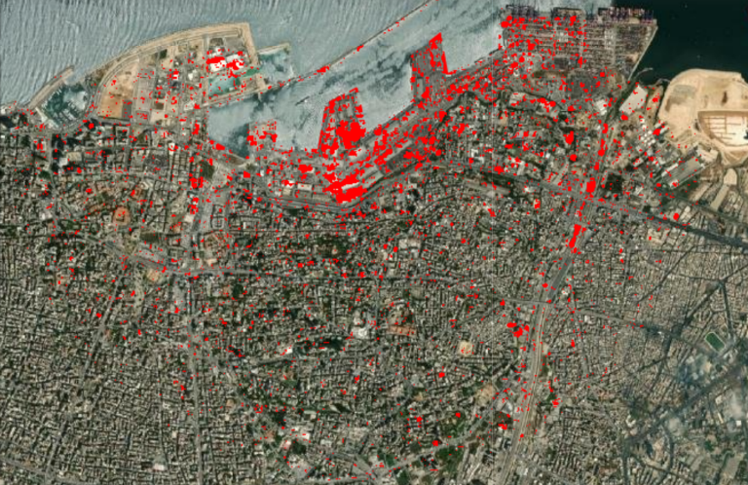

Figure : Areas of Statistically Significant Change

Now that the SAR change map has been created, populations falling within affected areas can be estimated. WorldPop, a peer-reviewed data archive produces data in raster format on human geography. Importantly, GEE provides access to WorldPop’s global population API at a spatial resolution of 100m, allowing it to be imported and analyzed. By vectorizing the SAR output, zonal statistics of population within affected areas can be calculated. Taking the maximum count of pixel values falling within areas of change, the results assessed 388,090 individuals to be affected by the explosion. According to reports, it is estimated approximately 300,000 individuals were left homeless or required extensive care (BBC News, 2020). Thus, the results of this study report an approximate accuracy of 77.3% in its ability to assess the impact the Beirut explosion would have on surrounding populations. A workflow of for reproducibility is visualized below.

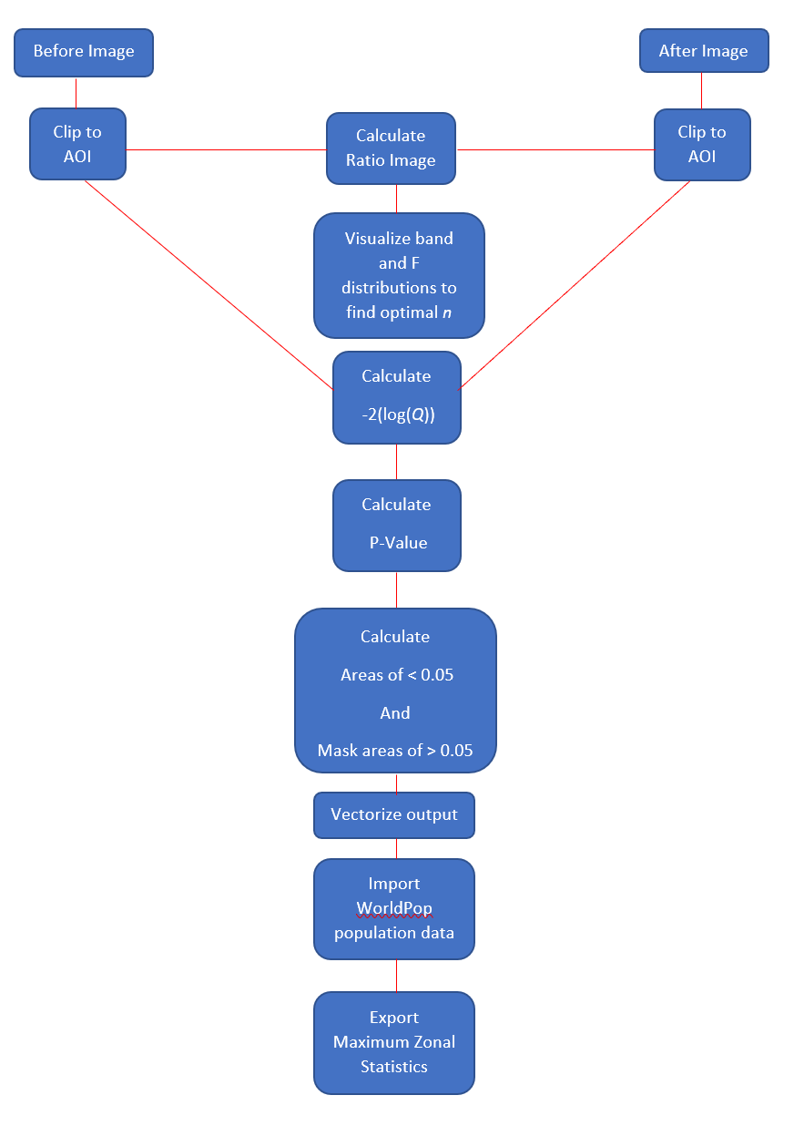

# Future Work

While this study produced promising results, there remain areas of improvement. Greater work needs to be done on the automation of this process, as an end-goal. Automating change detection within GEE requires also automating the process of identifying the correct value of *n* as well as achieving the same look angles. Using default values of preset orbits will likely produce suboptimal results as this process automated over the entire extent of the Earth will require a degree of care in each use case. Nonetheless, with the end-goal of automating change detection, this is an area of improvement.

Additionally, more work should be done on assessing proper parameters for applications outside of this case study. This work benefitted from the hindsight of after-action reports and well-established literature. However, in field applications, researchers will be deploying this workflow without priori knowledge of damage extent. Therefore, parameters such as the area of interest’s extent similarly must be automated. Future work will delve into assessing how researchers can determine the correct area of interest of an explosion prior to reports coming in.

# Conclusion

The application of SAR within cloud platforms such as GEE offer powerful tools for rapid open-source assessments of crises in near-real time. While much work has been done to date on the application of SAR for physical damage assessments, its use for mapping human recovery efforts has not yet been achieved but doing so would rapidly improve aid organizations’ contextual understanding of the resources necessary to assist in the aftermath of a large explosion. While GEE SAR datasets do not currently allow for InSAR analysis, the wealth of statistical methods provided by GEE allow for statistical change difference imaging. By vectoring this output and calculating zonal statistics of estimated population data, analysts can achieve approximately 77% accuracy in assessing the quantity of individuals impacted by an explosion as quickly as imagery is available.

##### Acknowledgment

Thank you to Dr. Phillips for providing me with the resources and knowledge to complete this work in support of the Explosion Explorer. This research will go towards improving the application and it could not have been conducted without proper instruction.

##### References

Evans, D., 1996. Bomb Damage Assessment and Sortie Requirements. *Military Operations Research,* *2*(1), 31-35. Retrieved May 5, 2021, from <http://www.jstor.org/stable/43943635>

Novikov G., Trekin A., Potapov G., Ignatiev V., Burnaev E., 2018. Satellite Imagery Analysis for Operational Damage Assessment in Emergency Situations. In: Abramowicz W., Paschke A. (eds) Business Information Systems. BIS 2018. Lecture Notes in Business Information Processing, vol 320. Springer, Cham. <https://doi.org/10.1007/978-3-319-93931-5_25>

ElGharbawi, T. and Zarzoura, F., 2021. Damage Detection Using SAR Coherence Statistical Analysis, Application to Beirut, Lebanon. *ISPRS Journal of Photogrammetry and Remote Sensing*, [online] 173, pp.1 - 9. Available at: <https://www.sciencedirect.com/science/article/pii/S0924271621000010> [Accessed 5 May 2021]

Rignot, E.J. and Van Zyl, J.J., 1993. Change detection techniques for ERS-1 SAR data. *IEEE Transactions on Geoscience and Remote sensing*, *31*(4), pp.896-906.

Bazi, Y., Bruzzone, L. and Melgani, F., 2005. An unsupervised approach based on the generalized Gaussian model to automatic change detection in multitemporal SAR images. *IEEE Transactions on Geoscience and Remote Sensing*, *43*(4), pp.874-887.

Inglada, J. and Mercier, G., 2007. A new statistical similarity measure for change detection in multitemporal SAR images and its extension to multiscale change analysis. *IEEE transactions on geoscience and remote sensing*, *45*(5), pp.1432-1445.

Samadi, F., Akbarizadeh, G. and Kaabi, H., 2019. Change detection in SAR images using deep belief network: a new training approach based on morphological images. *IET Image Processing*, *13*(12), pp.2255-2264.

Chen, Q., Yang, H., Li, L. and Liu, X., 2019. A Novel Statistical Texture Feature for SAR Building Damage Assessment in Different Polarization Modes. *IEEE Journal of Selected Topics in Applied Earth Observations and Remote Sensing*, *13*, pp.154-165.

Hajeb, M., Karimzadeh, S. and Fallahi, A., 2020. Seismic damage assessment in Sarpole-Zahab town (Iran) using synthetic aperture radar (SAR) images and texture analysis. *Natural Hazards*, *103*, pp.347-366.

Guida, L., Boccardo, P., Donevski, I., Lo Schiavo, L., Molinari, M.E., Monti-Guarnieri, A., Oxoli, D. and Brovelli, M.A., 2018. POST-DISASTER DAMAGE ASSESSMENT THROUGH COHERENT CHANGE DETECTION ON SAR IMAGERY. *International Archives of the Photogrammetry, Remote Sensing & Spatial Information Sciences*, *42*(3).

Gorelick, N., Hancher, M., Dixon, M., Ilyushchenko, S., Thau, D., & Moore, R. (2017). Google Earth Engine: Planetary-scale geospatial analysis for everyone. *Remote Sensing of Environment*.

Bito, C., 2020. *"There's nothing left": Beirut doctors say hospitals were so damaged by explosion, they had to turn away patients*. [online] Cbsnews.com. Available at: <https://www.cbsnews.com/news/beirut-explosion-hospitals-damaged-lebanon-patients-turned-away/> [Accessed 11 May 2021].

BBC News. 2020. *Beirut explosion: What we know so far*. [online] Available at: <https://www.bbc.com/news/world-middle-east-53668493> [Accessed 11 May 2021].